Project Deliverable 5 - Data Populations

Table Properties - Statistical Summaries
The screenshots below display the Properties panel for each entity in the schema, captured from MySQL Workbench. Each panel confirms the row count, average row length, data length, and additional storage statistics for the respective table.

Strong Entities

equipment (30 records)
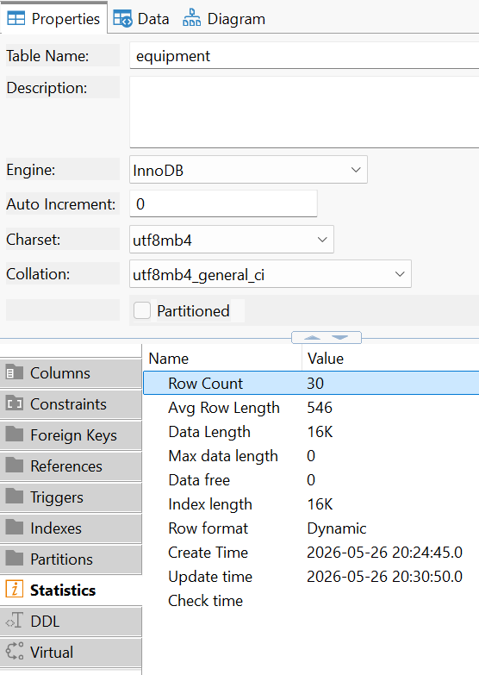

facility (30 records)
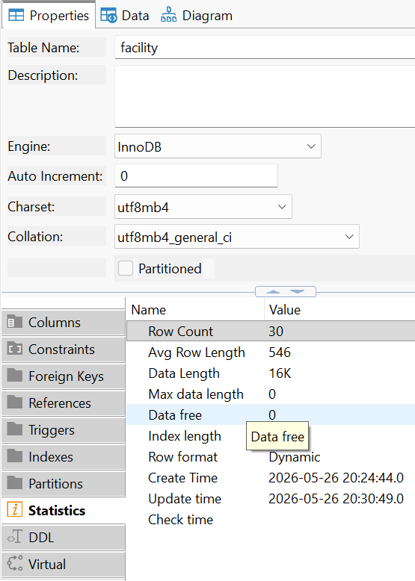

game (30 records)
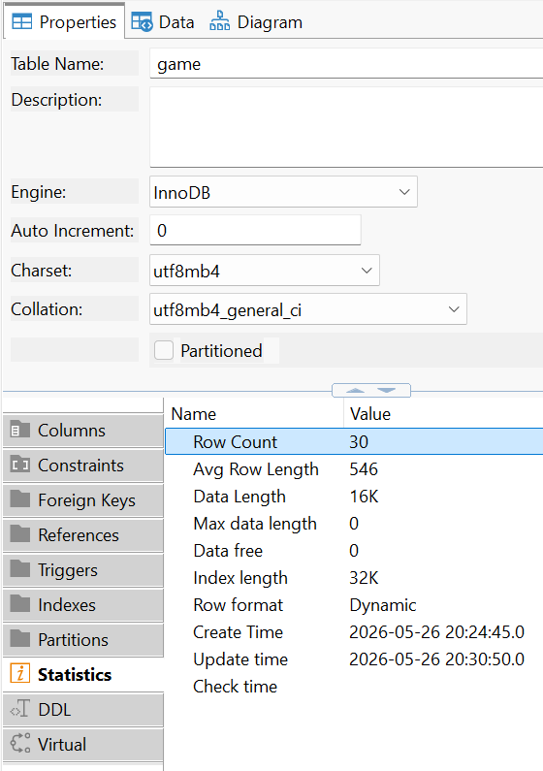

injury_record (30 records)
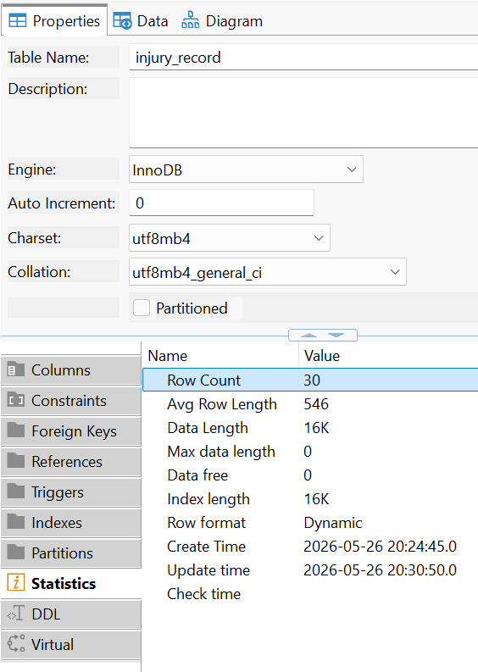

player (30 records)
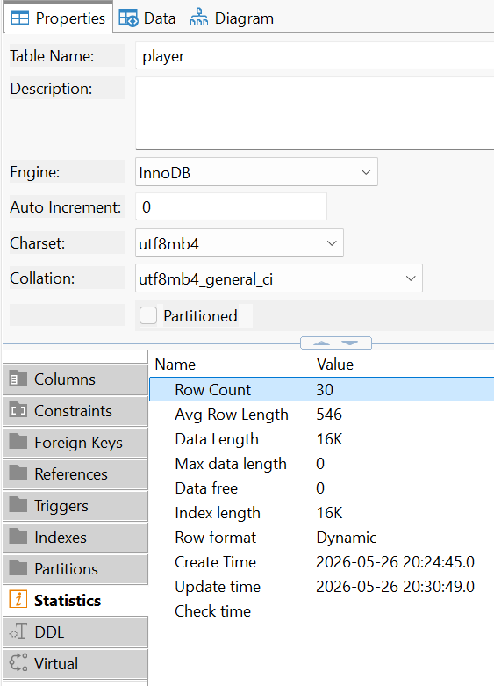

season (30 records)

staff (30 records)

team (30 records)

training_session (30 records)

Subtypes & Associative Entities

coach (15 records)

medical_staff (15 records)

game_roster (30 records)
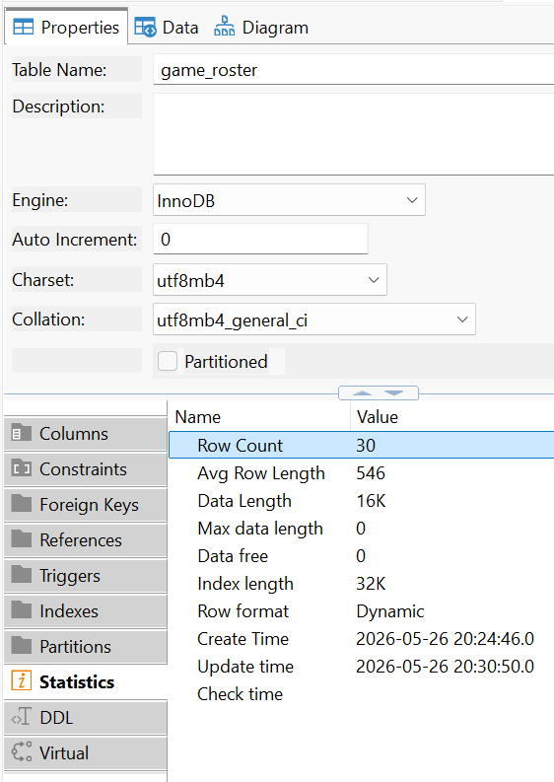

session_performance (30 records)

Record Count Query

The query below uses COUNT(*) and UNION operations to display each table name alongside its record count in a single result set, confirming that all minimum population requirements are met.

select 'coach' as 'Tables', count(*) as 'Records'
from coach
union
select 'equipment', count(*)
from equipment
union
select 'facility', count(*)
from facility
union
select 'game', count(*)
from game
union
select 'game_roster', count(*)
from game_roster
union
select 'injury_record', count(*)
from injury_record
union
select 'medical_staff', count(*)
from medical_staff
union
select 'player', count(*)
from player
union
select 'season', count(*)
from season
union
select 'session_performance', count(*)
from session_performance
union
select 'staff', count(*)
from staff
union
select 'team', count(*)
from team
union
select 'training_session', count(*)
from training_session;

Data Quality and Assumptions
Data Relevance:

All populated records were designed to align with the purpose of their respective tables and the relationships defined in the Entity-Relationship Diagram (ERD). The database models a realistic soccer management environment, including teams, players, games, training sessions, facilities, coaching staff, medical staff, equipment assignments, injury records, and player performance tracking.

Player records contain realistic names, dates of birth, positions, jersey numbers, and team assignments. Game and training session records were distributed across valid seasons and facilities, while injury and performance records were linked to existing players to maintain logical consistency throughout the database.

Referential Integrity:
Foreign key constraints were respected during population. Parent records were inserted before dependent child records, and all foreign key values reference valid primary keys in their parent tables.
Data Types and Formats:
All values conform to the column data types defined in the schema. Integer fields were populated with valid numeric values, VARCHAR attributes remained withtin specified character limits, and DATE fields followed the ISO 8601 standard format (YYYY-MM-DD).
Synthesized Data:
Records were synthetically generated to satisfy minimum count requirements and to provide a representative and varied dataset for use in subsequent reporting queries. The generated data simulates operations of sports teams in the real world, covering aspects such as player participation, injuries, training sessions, equipment assignments, and more. No real personally identifiable information was used.
Associative / Subtype Records:
Associative entity records were distributed to reflect realistic many-to-many relationships. Subtype records were assigned to cover each discriminator value present in the ERD.

ERD Reference
The Entity-Relationship Diagram below confirms the structural relationships among all populated tables. Data distribution was verified against this diagram to ensure logical consistency and referential integrity across the entire schema.

Validation Summary

No | Table | Type | Min Required | Actual Count | Status
1 | equipment | Strong Entity | 30 | 30 | Pass
2 | facility | Strong Entity | 30 | 30 | Pass
3 | game | Strong Entity | 30 | 30 | Pass
4 | Injury_record | Strong Entity | 30 | 30 | Pass
5 | player | Strong Entity | 30 | 30 | Pass
6 | season | Strong Entity | 30 | 30 | Pass
7 | staff | Strong Entity | 30 | 30 | Pass
8 | team | Strong Entity | 30 | 30 | Pass
9 | training_session | Strong Entity | 30 | 30 | Pass
10 | coach | Subtype | 10 | 15 | Pass
11 | Medical_staff | Subtype | 10 | 15 | Pass
12 | game_roster | Associative Entity | 10 | 30 | Pass
13 | session_performance | Associative Entity | 10 | 30 | Pass

